**Be Winter Ready**

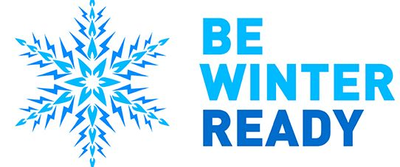

While electricity supplies are more reliable than ever, bad winter weather can cause damage and disruption. As winter approaches, there is an increased risk of experiencing severe weather. Storms, floods and other extreme conditions can cause damage to the electricity network and disrupt energy supplies.

In the event of severe weather, our teams work around the clock to repair any faults and restore supplies as quickly as possible, while keeping customers informed through a variety of channels, including social media and our [live power cut map](https://powercuts.westernpower.co.uk/tweets).

However, there are small steps people can take to make sure they are ‘winter ready’ and prepared for a power cut:

**Know your free emergency numbers**

In a power cut dial 105 or, for a gas emergency, dial [0800 111999](tel:0800%20111999)  
  
  
  
**Prepare your home**

Keep a torch handy and get your appliances serviced by a Gas Safe registered engineer to prevent carbon monoxide poisoning. Vulnerable households can get extra support by signing up to the [Priority Services Register](https://www.nationalgrid.co.uk/customers-and-community/priority-services).  
  
**Keep your eyes open**

Keep an eye on the weather forecaster and, if you have a power cut or a gas emergency, check on your neighbours.

**The Priority Services Register**

The Priority Services Register is a free service provided by the company and is eligible for anyone who is of a pensionable age, disabled, has children under 5 years old or relies on medical equipment.

As part of the service, customers are kept informed as much as possible of power cuts affecting their home and are given special help, if needed, through the British Red Cross.

The Priority Services Register offers peace of mind for vulnerable customers and their families and we do our very best to ensure that their needs are met at all times.

We already have **1.9 million** customers on our register.

To find out more information or to register, please call us on [**0800 096 3080**](tel:0800%20096%203080)

Emergency Information

[**0800 6783 105**](tel:0800%206783%20105)

General contact enquiries

[**0800 096 3080**](tel:0800%20096%203080)

<https://www.nationalgrid.co.uk/be-winter-ready>

**What to do during a Powercut**

Prepare:

* Follow your [network operator](https://www.energynetworks.org/customers/find-my-network-operator) on social media so you can find local updates. Social media and your local network operator’s website are the best places for key updates and restoration times in storms or emergencies.
* Save 105, the free national power cut emergency number, to your phone. In Northern Ireland, call 03457 643643. In the Republic of Ireland, call 1850 372 999.
* Keep a mobile phone fully charged so you can use it to go online for updates or call if you have a power cut.
* Keep a torch handy in case you are without power during the night.
* Switch off all electrical appliances that shouldn’t be left unattended, ready for when the power comes back on.
* Leave a light on so you know when the power cut has been fixed.

Care:

* Check to see if your neighbours are safe and if they have a power cut too. If they have power, your trip switch may have activated.
* Ensure your household and your neighbours have warm clothes, blankets and food which doesn’t need heating accessible.
* Check to see if you or someone you know can get extra help during bad weather through the [Priority Services Register](https://www.energynetworks.org/be-winter-ready).

Share:

* Share this information and the [energynetworks.org/be-winter-ready](https://www.energynetworks.org/be-winter-ready) website with others.

Need extra help?

The energy networks can help if you have additional needs because of your medical or personal circumstances.

If you are on your local network operator’s free [Priority Services Register](https://www.energynetworks.org/customers/extra-help-for-customers), they will prioritise getting help to you first in an emergency.

Being on a Priority Services Register won’t mean your electricity supply will be restored more quickly in a power cut. But you could get:

* heating and cooking facilities
* accommodation
* regular direct updates, such as by telephone.
* advanced notice of planned power cuts.

If your power has gone out and you are not yet registered for Priority Services support but need help, tell your [network operator](https://www.energynetworks.org/customers/find-my-network-operator) now so they know.

<https://www.energynetworks.org/customers/power-cut>