Introduction
Healthwatch Norfolk is situated on Norwich Common, between Hethersett and Wymondham. The office is 8.5 miles (13.6km) from Norwich Railway Station. It takes around 21 minutes to drive here from the station. There are regular buses to the venue (see below for details).
We look forward to welcoming you to any meetings or events that you have registered for. If you have any queries or require any assistance, please phone us on 0808 168 9669 or email enquiries@healthwatchnorfolk.co.uk
Download this Access Statement as a Word document.

Arrival
Healthwatch Norfolk is located on Norwich Common. There is a bus stop just outside. Bus numbers 6, 6A, 3B and 90 all stop here. The car park is shingled and there are paving slabs which slope towards the entrance.
Taxi companies that will take wheelchairs in Norwich include:
Express Wheelchair Taxis | 01603-339091 | Wheelchair taxis available
A2B Taxis | 01603-552324 | Wheelchair taxis with ramps, with chaperones a take bookings on the day!
Freedom Transport | 01603-652037 | Wheelchair taxis available
ABC Taxis Norwich | 01603-666333 | Can transport passengers with foldable wheelchairs
Courtesy Taxis | 01603-446644 | Wheelchair accessible taxis with ramps available.
Goldstar Taxis | 01603-700700 | Wheelchair accessible taxis available

Car parking and drop-off facilities
We have car parking with designated disabled parking which is marked by signage. Cars can drop off near the main entrance.

Entrance
There is a visitor entrance to the rear of the building and a barrier entrance to the front of the building. The door of the main entrance is clear glass and quite heavy. To enter the building, there is an intercom set-up at the right-hand side of the main entrance. Once the intercom buzzer is pressed, a staff member can come downstairs and help with the door. Healthwatch Norfolk is located on the upper level. There is a platform lift which is directly ahead of the main entrance.
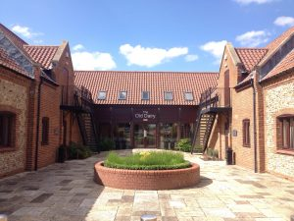The entrance outside The Old Dairy, Elm Farm
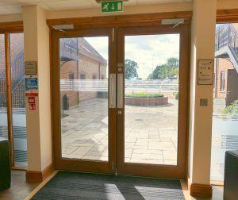The entrance inside The Old Dairy, Elm Farm

Inside the office
Healthwatch Norfolk is a spacious office with desks positioned either side of the room. The floor is carpeted and level throughout and there is ample circulation space around the desks for wheelchair users. The main office is lit by fluorescent lights. Staff are happy to assist visitors where necessary.
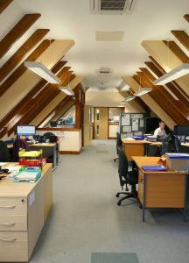Inside the office

Meeting room
There is a meeting room at the end of our main office which has beams each side of the room but is a large space with no fixed furniture and can therefore be moved around to suit users.

Accessible toilet
There is an accessible toilet on the ground floor and the first floor.
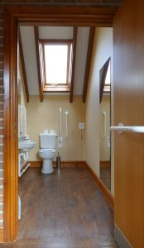

Lifts
There is one platform lift in the building which covers the first and second floor. Please note, this lift is not suitable for power chairs.
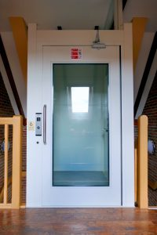Platform Lift

Other Information
- There are power points for electronic devices, should they be required by visitors.
- We welcome assistance dogs and water bowls can be provided.
- If you require any of our information in an alternative format, please contact us.

Contact Information
Address: Suite 6- Elm Farm, Norwich Common, Norfolk, NR18 0SW
Telephone: 0808 168 9669
Email: enquiries@healthwatchnorfolk.co.uk
Website: www.healthwatchnorfolk.co.uk
This access statement does not contain personal opinions as to our suitability for those with access needs, but aims to accurately describe the facilities and services that we offer all our guests/visitors.
If you require this information in an alternative format, please contact us at enquiries@healthwatchnorfolk.co.uk or call us on 0808 168 9669

